**Mettler-Toledo TGA/DSC 3+ GmbH, Analytical, Germany**

TGA/DSC measures the mass of the sample and energy absorbed as it is heated or cooled. The instrument offers the automatic adjustment of mass, temperature and the inert atmosphere. The system is installed with Star e software programmed with ASTM E698 useful is studying the thermodynamic and kinetic parameters.

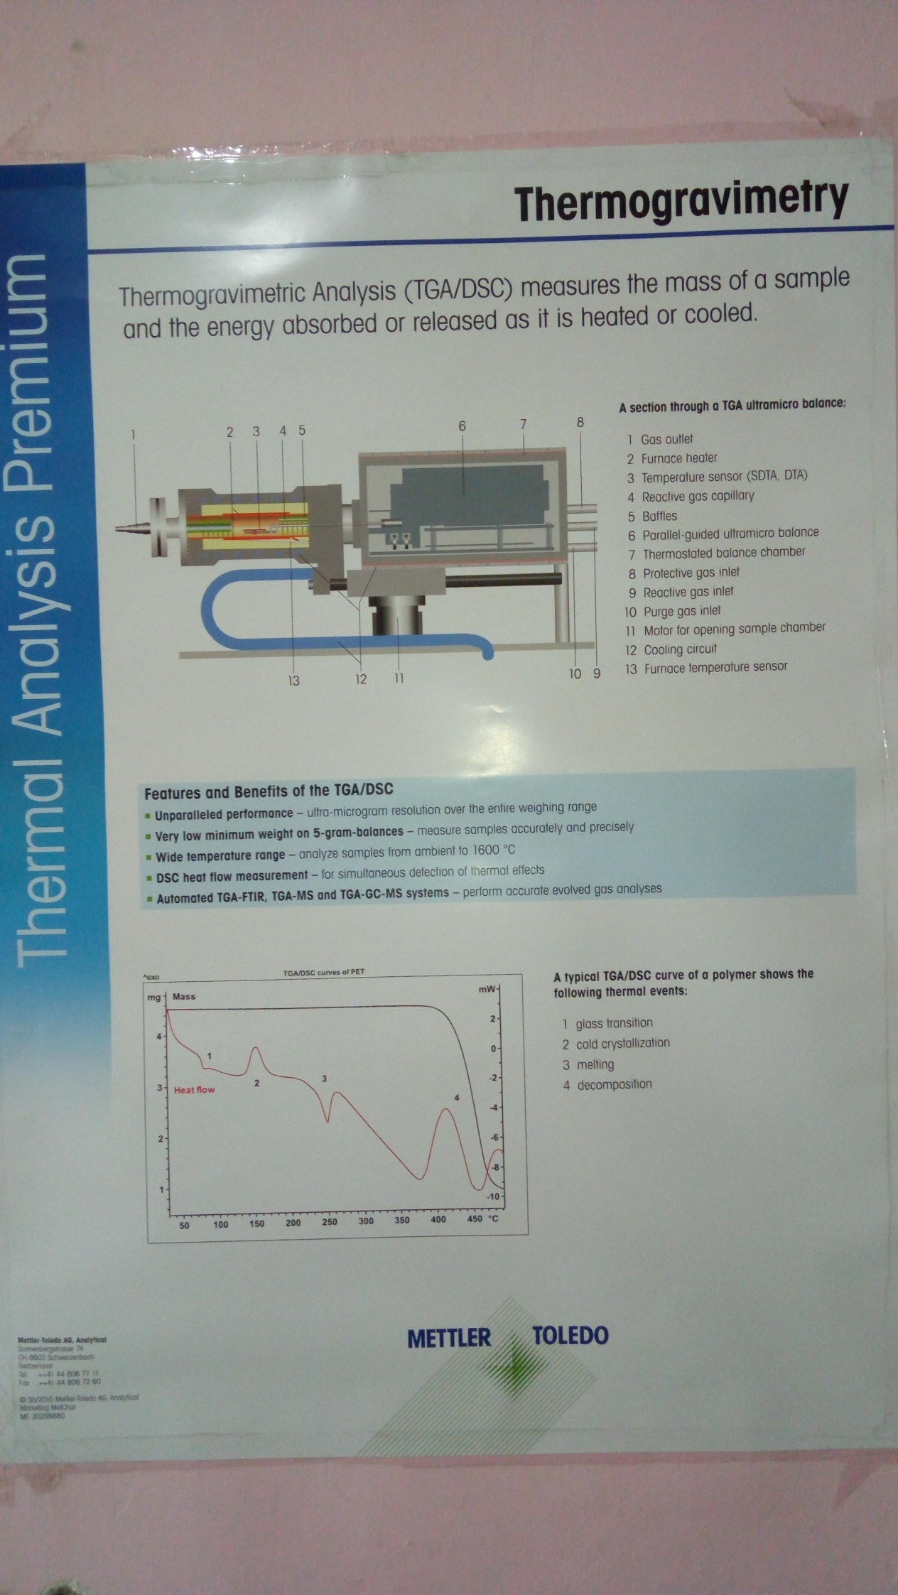 **A section through a TGA ultra microscope balance**:

1. Gas outlet

2. Furnace Heater

3. Temperature sensor (SOTA, OTA)

4. Reactive gas capillary

5. Baffles

6. Parallel guided ultra microbalance

7. Thermo stated balance chamber

8. Protected gas inlet

9. Reactive gas inlet

10. Purge gas inlet

11. Motor for opening sample chamber

12. Cooling circuit

13. Furnace temperature sensor

* **Features and benefits of the TGA/DSC**

1. **Unparelled performance**-ultra micro performance over the entire weighing range.
2. **Very low minimum weight of 5gms on balances-**measure samples accurately and precisely.
3. **Wide temperature range**-analyze samples from ambient to 1600oC
4. **DSC heat flow measurement**-for simultaneous detection of thermal effects.
5. **Automated TGA-FTIR, TGA-MS, TGA-GCMS systems**-perform accurate evolved gas analysis.

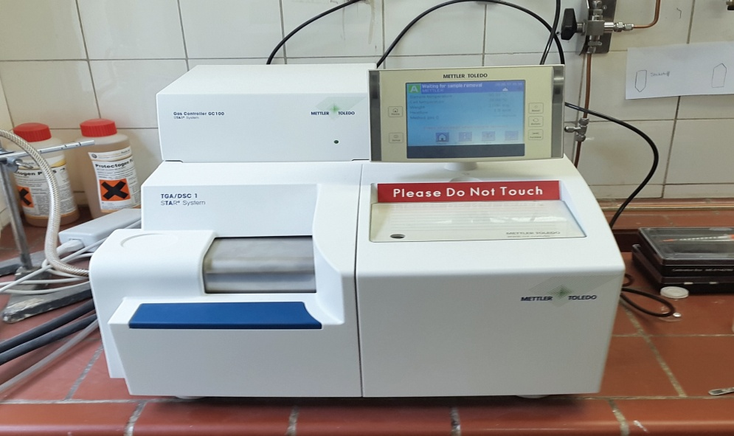

***Teacher Incharge:***

***Dr. Kowsar Majid***

***Associate Professor***

***Room No. 229***

***Department of Chemistry***

***NIT Srinagar***

TGA/DSC