MOEDL QUESTIONS FOR EXAMINATIONS
By Dr. M A shah
………………………………………………………………………………………………..
Q.1. (a) The intrinsic Carrier concentration of germanium at room temperature is 2.5x10¹⁹ m⁻³. It is doped with Phosphorus at the rate of 1 phosphorus atom per million atoms of germanium. If the concentration of germanium atom is 5x10²⁸ m⁻³, calculate the hole concentration. Assume complete ionization of phosphorus atoms.
(b) Find the bandgap of semiconductor, when the electrical conductivity of a semiconductor increases when electromagnetic radiations of wavelength shorter than 2480nm are incident on it.?
Q.2. (a) Silicon contains 5x 10²⁸ atoms per m³. In an n-type silicon sample the donar concentration is 1 atom per 2.5x 10⁷ Si atoms. Assuming that the electron effective mass is equal to the true mass, calculate the temperature at which the Fermi level lies at the bottom of the conduction band.
(b) Show graphically the variation of energy with wave number k for the first allowed band in a solid? Hence explain the variation in sign of the effective mass of an electron in the band?
Q.3. (a) Explain the working of FET or MOSFET?
(b) the current through a p-n junction diode is 55ma at a forward bias voltage of 3.0 V. If the temperature is 27⁰C, find the static and dynamic resistance of the diode?

Q.4. (a) Explain Flip flops in detail with their symbols and truth tables?
(b) Identify the type of logic gate shown in the schematic diagram and explain why it has name it does?
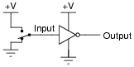
Implement Z = A.B + C.D¯ using only NAND gates or NOR gates
Q.5. (a) The circuit depicted below has been made with a silicon n-p-n transistor. Assume that there will a 0.7V drop across a forward biased silicon p-n junction; the power dissipated across the transistor will be approximately?
(b) Are the collector and emitter terminals of a transistor interchangeable? If not, what is the physical difference between the emitter and collector?
Q.6. (a) Discuss the splitting of energy bands in silicon?
(b) Qualitatively, in terms of energy bands, discuss the difference between a metal, an insulator,
and semiconductor?.
Q.7. (a) Calculate the intrinsic carrier concentration, at T = 200, and 400K for
(1) Silicon, (2) germanium
(b) Two semiconductor materials have exactly the same properties except material A has a bandgap energy of 0.90 eV and material B has a band gap energy of 1.10 eV. Determine the ratio of of material B to that of material A for T =200 K.
Q.8. (a) Calculate the thermal equilibrium electron and hole concentration in silicon at T = 300 K for the case when the Fermi energy level is 0.22 eV below the conduction-band energy. Taking equal to 1.12ev?
(b) Calculate the position of the intrinsic Fermi level with respect to the center of the band gap in silicon at T =300 K. The density of states effective carrier masses in silicon are =1.08 and =0.56
Q.9. (a) How does the electron concentration in the conduction band change with energy E for
E > ?
(b) Two semiconductor materials have exactly the same properties except material A has a bandgap energy of 0.90 eV and material B has a band gap energy of 1.10 eV. Determine the ratio of of material B to that of material A for T = 200 K.
Q.10. (a) Given the effective masses of electrons and holes in silicon, germanium, and gallium arsenide, calculate the position of the intrinsic Fermi energy level with respect to the center of the band gap for each semiconductor at T=300 K.
(b) Under what condition would the intrinsic Fermi level be at the midgap energy?
Q.11. (a) A silicon transistor with built in voltage 0.7V is used in the circuit shown, with =9.7V, =300KΩ, =2V and =2KΩ. Using the data draw the load line and quiescent point Q.

(b) For the circuit shown, find the potential (in volts) across.
Q.12. (a) Describe the mechanism of charge flow across the space charge region of a pn junction when a forward-bias voltage is applied.
(b) Consider an ideal pn junction diode at T =300 K operating in the forward-bias region. Calculate the change in diode voltage that will cause a factor of 10 increase in current.
Q.13. (a) Explain the basic operation of the MOSFET. Discuss the I–V characteristics of the MOSFET.
(b) Define enhancement mode and depletion mode for both n-channel and p-channel devices.

Q.14 (a) Define and, and explain why .
(b) What are α,β and γ in a transistor. Why inverse active mode of transistor is not useful?
Q.15 (a) Describe the basic operation and characteristics of a solar cell, including the short-circuit
Current and open-circuit voltage.
(b) Explain the basic operation of an LED. State two factors that affect the efficiency of the
Device.
Q.16. (a) A sample of GaAs is 1.2 m thick. The sample is illuminated with a light source that generates photons with energies of 1.65 eV. Determine the (i) absorption coefficient and (ii) fraction of energy that is absorbed in the material.
(b) Consider a silicon semiconductor that is illuminated with photons with energies 1.40 eV. Determine the thickness of the material such that 90 percent of the energy is absorbed.
Q.17. (a) A bulb in staircases has two switches, one switch being at the ground floor and the other one at the first floor. The bulb can be turned ON and also can be turned OFF by and one of the switches irrespective of the state of the other switch. Determine the logic gate.
(b) Calculate the minimum number of NAND gates required to implement the Boolean function A+𝐴 + 𝐴𝐶 .
Q.18. (a) Write a boolean expression and truth table for the output, Q, in terms of the inputs A, and B.
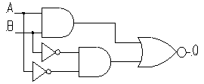
(b) Draw a logic circuit for (C + D).

Q.19. (a) The intrinsic carrier density is 1.5 × 10¹⁶ m^{–3}. If the mobility of electron and hole are 0.13 and 0.05 m² V^{–1} s^{–1}, calculate the conductivity.
(b) The Intrinsic carrier density at room temperature in Ge is 2.37 × 10¹⁹ m³ if the electron and hole mobilities are 0.38 and 0.18 m² V^{–1} s^{–1} respectively, calculate the resistivity.
Q.20. (a) An N-type semiconductor has hall coefficient = 4.16 × 10⁻⁴ m³ C⁻¹. The conductivity is 108ohm m⁻¹. Calculate its charge carrier density ‘’and electron mobility at room temperature.
(b) For an intrinsic Semiconductor with a band gap of 0.7 eV, determine the position of at T = 300 K if m*h = 6m*e.

Q.21. (a) Find the current and output voltage in the following figure.

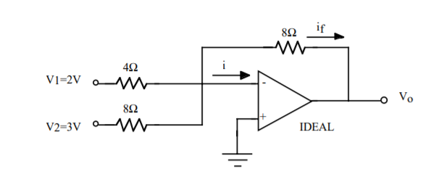

(b) Discuss the characteristics of an operational Amplifier. Obtain expressions for voltage gain for inverting and non inverting amplifier?
Q.22. (a) Draw the truth tables of SR flip flop and JK flip flop and explain the advantage of JK flip flop over SR flip flop?
(b) Explain with help of diagram how SR flip flop can be converted into T flip flop?
Q.23. (a) On the fifth clock pulse, a 4-bit Johnson sequence is Q0 = 0, Q1 = 1, Q2 = 1, and Q3 = 1. Determine the sequence on the sixth clock pulse?
(b) Design an asynchronous counter that has the following properties: i. the counter is a MOD 6 counter. ii. The counter sequence direction is counting up. iii. The counter consists of active-low JK Flip flop.
Q.24 (a) Show the logic circuit for Y = AB’ + AB. Next simplify this Boolean equation and the corresponding circuit.
(b)Given the following truth table. Obtain the simplified function in sum of products.
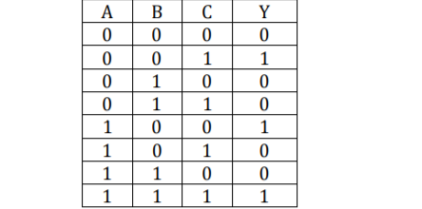
Q.25. (a) What is Half adder and Full adder? How many flip-flops are required to make a MOD-32 binary counter?
(b) Define Multiplexer. Draw a block diagram for 4 x 1 lines MUX

