Hematite (α-Fe₂O₃) Nanosheets with Enhanced Photo-electrochemical Ability
Jaffar Farooq Mir¹, S Rubab¹ and M A Shah^{1*}
¹Special Centre for Nanoscience, Department of Physics, National Institute of Technology Srinagar, Hazratbal-Srinagar, 190006 (J&K), India
*shahji@nitsri.net
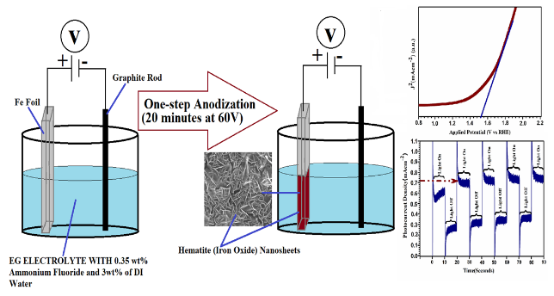

We report synthesis of hematite nanosheets and their photocurrent response, which were fabricated through a single step-anodization technique at room temperature in our laboratory. Light absorption study of nanosheets, using diffuse-reflectance-spectroscopy, depicts the band gap of ~2.18 eV. Photocurrent density of as-fabricated nanosheets is found to be ~0.72 mA cm⁻². The enhanced photocurrent density as compared to iron oxide based photo-electrodes can be attributed to high surface area for light absorption and good crystallinity. These features improve the charge separation to overcome charge carrier recombination which favours their preference as a promising candidate for visible-light driven applications. To the best of our knowledge, fewer reports are available regarding photo electrochemical ability of hematite nanosheets.

In the direction, photo-electrochemical ability of hematite (α-Fe₂O₃) nanosheets of about 270 nm in length with high phase purity, directly grown on Fe foil via anodization of iron foil in a ﬂuoride containing solution have been studied. The experiment have been designed and carried at NIT Srinagar and are being used to fabricate other metal oxides.
The low-cost materials, simple fabrication process, and excellent chemical stability demonstrated in this study highlight the key features that differ from other studies which require the use of expensive metals, organics and complicated fabrication process. The new findings will pave the way toward low-cost, more efficient, and stable photoelectrochemical system for sustainable solar energy conversion and other applications.

Keywords: Hematite nanosheets; photocurrent density: anodization; Urbach Energy; Photo electrode.
References:
- Mir JF, Rubab S, Shah MA. Photo-electrochemical ability of iron oxide nanoflowers fabricated via electrochemical anodization. Chemical Physics Letters. 2020 Feb 16;741:137088.
- Shah M A and Tokeer A, Principles of Nanoscience and Nanotechnology, I.K International, Pvt. Ltd, New Delhi 2020
Bibliography:- 3-5 Lines

