PN Junction Diode
(Semiconductor Diode)
A pn junction is known as a semiconductor diode.
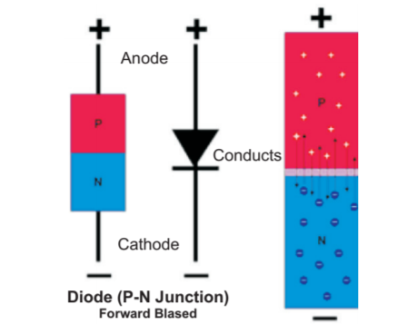
It is also known as crystal diode since it is grown out of a crystal (like germanium of silicon). A semiconductor diode has two terminals. Its symbol is shown in fig.-6. It conducts only when it is forward biased i.e when terminal connected with overhead is at higher potential than the terminal connected to the bar. However when it is reversed biased practically it does not conduct any current through it.
Depletion Layer
A region around the junction from which the charge carriers (free electrons and holes) are depleted is called depletion layer.
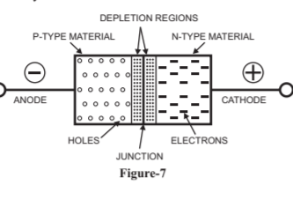
Potential Barrier
A potential difference built up across the pn junction which restricts further movement of charge carriers across the junction is known as potential barriers.
Forward & Reverse Biasing
When a pn junction is connected across an electric supply (potential difference) the junction is said to be under biasing. The type of biasing can be
- Forward Biasing
When the positive terminal of a d.c. source or battery is connected to p-type and negative terminal is connected to n-type semiconductor of a pn junction, the junction is said to be in forward biasing the following points are worth noting, when a junction is forward biased:
- The junction potential barrier is reduced and at some forward voltage (0.3 v for germanium and 0.7 v for silicon). It is eliminated altogether.
- The junction offers low resistance to the flow of current through it.
- The magnitude of flow of current through the circuit depends upon the applied forward voltage.
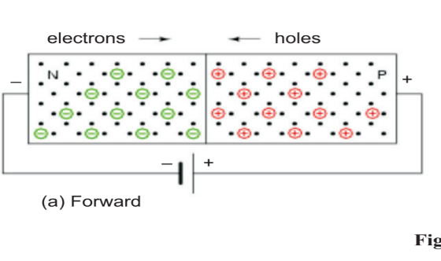

(b)Reverse Biasing
When the positive terminal of a d.c. source or battery is connected to n-type and negative terminal is connected to p-type semiconductor of a pn junction, the junction is said to be in reverse biasing. The following points are worth noting, when a junction is forward biased:
- The junction potential barrier is strenghened.
- The junction offers high resistance to the flow of current through it.
- The magnitude of flow of current through the circuit depends upon the applied reverse voltage.
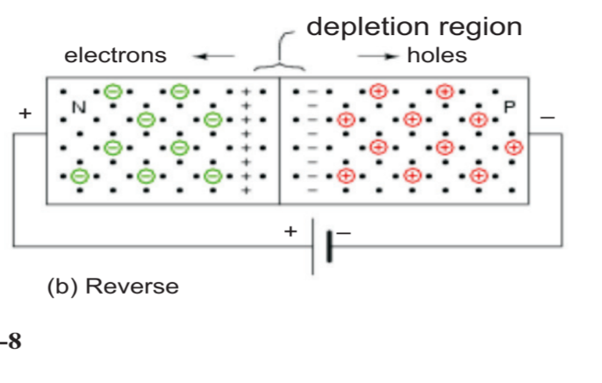
V-I Characteristic of Semiconductor
The volt ampere (v-i) characteristics of a pn junction is just a curve between voltage across the junction and the circuit current. To draw the curve the circuit is arranged. In the circuit it is important to note that a resistor R is connected in series with the pn junction which limits the forward diode current from exceeding the permitted value. The characteristics are studied under three heads viz. zero external voltage, forward biasing and reverse biasing.
- Zero External Voltage:When no external voltage is applied i.e circuit is open at key k. no current flow through the circuit. It is indicated by points 0 on the graph.
- Forward Biasingpositi: When key k is closed and double pole double throw switch is thrown to position 1. the pn junction is forward biasd as p-type semiconductor is connected to the ve terminal and n-type to the negative terminal of the supply. Now when supply voltage is increased by changing the variable resistor R the circuit current increases very slowly and the curve is non linear. The slow rise in current in this region is because the external applied voltage is used to overcome the potential barrier (0.3V for Ge and 0.7V for Si) of the pn junction. However once the potential barrier is eliminated and external voltage is increased further the pn junction behaves like an ordinary conductor and the circuit current rises very sharply. At this instant the circuit current is limited by the series resistance R and a small value of the junction forward resistance R. The curve is almost linear. If the current rises more than the rated value of the diode the diode may change

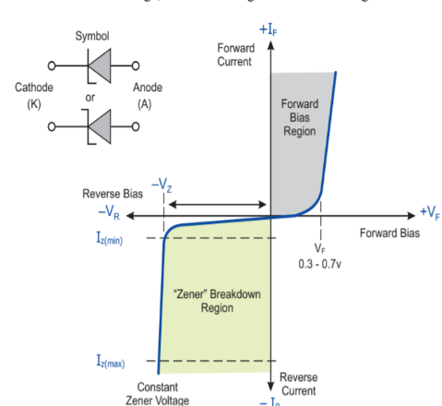
- Reverse Biasing:When the double pole double throw switch is thrown to position 2, the pn junction is reverse biased as p- type semiconductor is connected to the negative terminal and ntype to the positive terminal of the supply. Under this condition the potential barrier at the junction is increased. Therefore the junction resistance becomes very high and practically no current flows through the circuit. However in actual practice a very small current flows in the circuit as shown, this current is called reverse current and is due to minority carriers available at room temperature in the two types of semiconductor. The reverse bias appears as a forward biased for these undesirable minority carriers and thus they constitue a minor current in reverse direction. The reverse current increases slightly with the increase in reverse bias supply voltage. The reverse voltage at which pn junction breaks in known as breakdown voltage.
Breakdown in Junction Diode
The breakdown of the pn junction can be of two types, these are
- Avalanche Breakdown
For thicker junctions the breakdown mechanism is by the process of avalanche breakdown. In this mechanism when the electric field existing in the depletion layer is sufficiently high, the velocity of the carriers (minority carriers) crossing the depletion layer increases. These carriers collide with the crystal atoms. Some collisions are so violent that electrons are knocked off the crystal atoms, thus creating electron hole pairs as the pair of electron hole is created in the midst of the high field, they quickly separate and attain high velocities to cause further pair generation through more collisions. This is cumulative process and as we approach the breakdown voltage, the field becomes so large that the chain of collisions can give rise to an almost infinite current with very slight additional increase in voltage. The process is known as avalanche breakdown. Once this breakdown occurs, the junction cannot regain its original position.Thus the diode is said to be burnt off.
Zener Breakdown
This breakdown takes place in a very thin junction i.e. when both sides of the junction are very heavily doped and consequently the depletion layer is narrow. In the zener breakdown mechanism, the electric field becomes as high as 10^7 v/m in the depletion layer with only a small applied reverse bias voltage. In his process it becomes possible for some electrons to jump across the barrier from the valence band in p- type material to some of the unfilled conduction band in n-material. This process is known as zener breakdown. In this process the junction is not damaged.
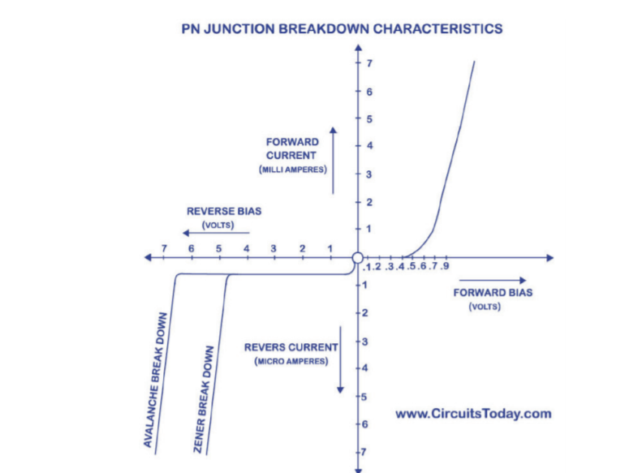
Zener Diode
A specially designed silicon diode which is optimised to operate in the breakdown region is known as aszener diode.
Characteristics of Zener Diode
- Its characteristics are similar to an ordinary diode with the exception that it has a sharp (or distinct) breakdown voltage called zener voltage v_{z}.
- It can be operated in any of the three region i.e. forward, leakage or breakdown. But usually it is operated in the breakdown region as shown in above figure.
- The voltage is almost constant (v_{z}) over the operating region.
- Usually, the value of v_{z} at particular test current I_{zr} is specified in the data sheet.
- During operation it will not burn as long as the external circuit limits the current flowing through it below the burn out value i.eI_{zr} (the maximum rated zener current).
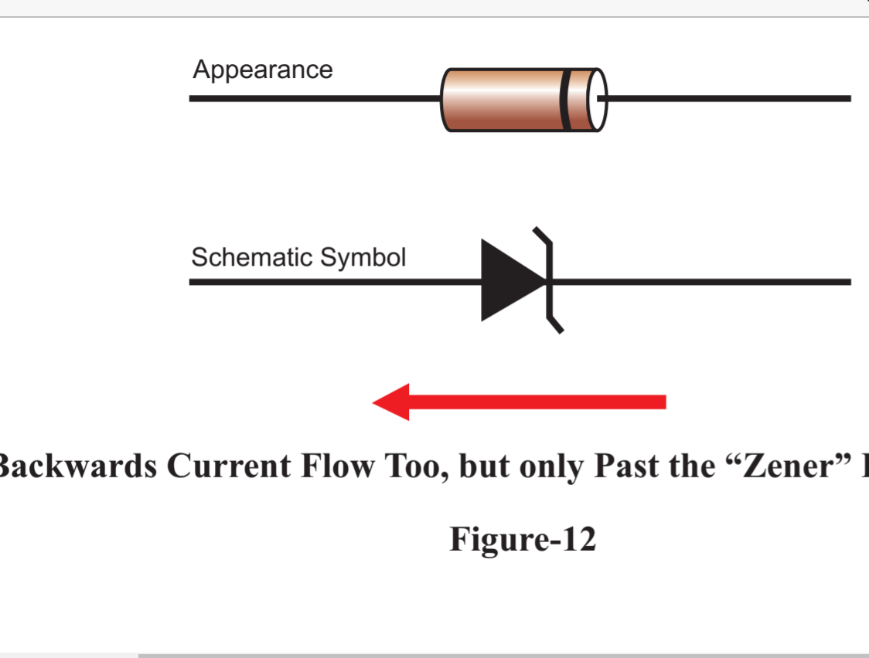
Application
- Meter Protection
- Voltage Regulator
- Wave Shaping Circuit
Photo Diode
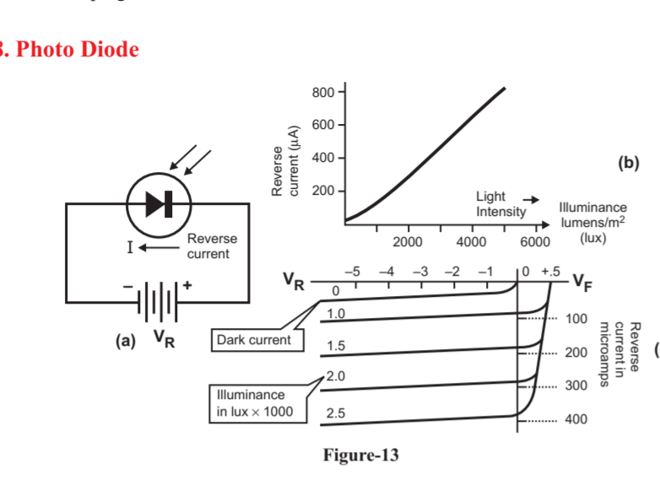

When a diode is reverse biased a minute current flows in the diode due to minority carriers. These carriers exist because of thermal energy which dislodge the valence electrons from their orbits producing free electrons and holes in the process.
When light energy falls on a pn junction, it also imparts energy to dislodge valence electron. In other words the amount of light striking on the junction can control the reverse current in a diode. A diode that is optimised for its sensitivity to light is known as photo diode.
LED (Light Emitting Diode)
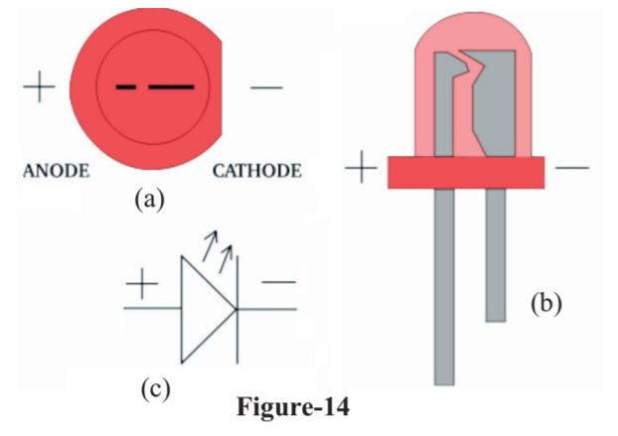
When a diode is forward biased the potential barrier is lowered. The conduction band free electrons from n- region cross the barrier and enter the p-region, as these electrons enter the p- region they fall into the holes lying in the valence band. Hence they fall from a higher energy level to a lower energy level in the process they radiate energy. The LED are different. These are made of gallium arsenide phosphide (GaAsP) and gallium phosphide (GaP). In LED the energy is radiated in the form of light and hence they glow. A manufacturer can produce LED that radiate red, green, yellow, blue, orange light.
Application
Instrument display, panel indicators, digital watches, calculator etc.
Diode as a Rectifier
The electrical power is generated transmitted and distributed as d.c. for economical reasons. As an alternating voltage is available at the mains. But most of the electronic circuit need d.c. voltage for their operation. Therefore the rectifier is the heart of power supply. The rectifier can be of two types:
- Half Wave Rectifier
- Full Wave Rectifier
- Half Wave Rectifier
In half wave rectifier when a.c. supply is applied at the input only positive half cycle appears across the load, whereas the negative half cycle is suppressed.
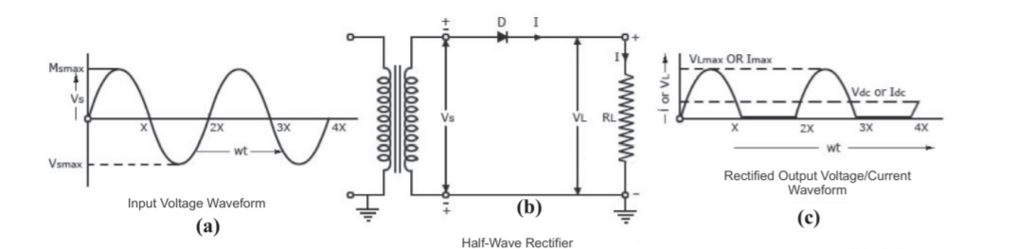
Circuit
For half wave rectification only one crystal diode is used. It is connected in the circuit as shown in fig. 15 the a.c. supply to be rectified is generally given through a transformer. The transformer is used to step down or step up as per requirement. It also isolates the rectifier circuit from power lines and thus reduce the risk of electric shock.
operation
when an a.c. supply is switched on, the alternating voltage (Vin) as shown fig.-15(a). Appears across the terminal AB at secondary winding. During positive half cycle. The terminal A is positive w.r.t. B and the crystal diode is forward biased. Therefore it conducts and current (i) flows through the load resistor RL. This current varies in magnitude as shown fig.-15(c). Thus a positive half cycle of the output voltage appears, across the load resistor as shown.
During the negative half cycle the terminal A is negative w.r.t. B and the crystal diode is reverse biased. Under this condition the diode does not conduct and no current flows through the circuit.
- Full Wave Rectifier
Fig. shows the circuit of a full wave bridge rectifier. In this case aan ordinary transformer is used in place of a centre taped transformer. The circuit contains four diodes D1, D2, D3 and D4 connected to form a bridge. The a.c. supply to be rectified is applied to the diagonally opposite ends of the bridge. Whereas the load resistor RL is connected across the remaining two diagonally opposite ends of the bridge.
Operation
When an a.c. supply is switched on, the alternating voltage Vin appears across the terminal AB of secondary winding of transformer which needs rectification. During positive half cycle of secondary voltage the end A becomes positive and end B negative. This makes diode D1 and D3 forward biased and diodes D2 and D4 reverse biased. Therefore diodes D1 and D3 conduct while diodes D2 and D4 do not. Thus current (i) flows through diode D1, load resistor RL diode D3 and the transformer secondary as shown 16(c). The wave shape is shown in fig. 16(b). During negative half cycle of secondary voltage the end A becomes negative and end B positive. This makes diode D2 and D4 forward biased and diodes D1 and D3 reverse biased. Therefore diodes D2 and D4 conduct while diodes D1 and D3 do not. Thus current (i) flows through diode D2, load resistor RL diode D4 and the transformer secondary as shown. The wave shape is shown in fig.
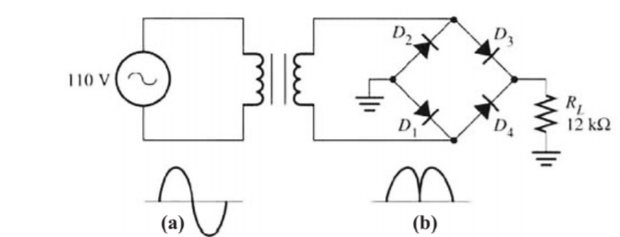
Zener Diode Regulator
The major application of zener diode in the electronic circuit is as a voltage regulator. It provides a constant voltage to the load from a source whose voltage may vary over sufficient range. The zener diode of zener voltage V_{z} is reverse connected across the load R₁ across which constant voltage is desired. A resistor R is connected in series with the circuit which absorbs the output voltage fluctuation so as to maintain constant voltage (V₀) across the load.
Let a variable voltage Vin be applied across the load R₁. When the value of Vin is less than zener voltage V_{z} of the zener diode. No current flows through it and the same voltage appears across the load. When the input voltage Vin is more than V_{z} this will cause the zener diode to conduct a large current I_{z} .
In the above discussion it has been seen that when a zener diode of zener voltage V_{z} is connected in reverse direction parallel to the load. It maintains a constant voltage across the load equal ypVz and hence stablises the output voltage.
