**Experimental and numerical developments on the fixation of orthopedic implants: Tribological behavior**

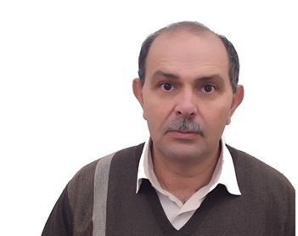

Keynote speaker: Maher DAMMAK

Professor Mechanical Engineering

Department of Technology, Preparatory School for Engineering Studies of Sfax, Tunisia

Laboratory of electromechanical systems (LASEM), National Engineering School of Sfax, University of Sfax, Sfax, Tunisia,

[maher.dammak@ipeis.rnu.tn](mailto:maher.dammak@ipeis.rnu.tn)

Professor Maher Dammak obtained his Ph.D, 1995 in Mechanical Engineering from Polytechnic School of Montreal, Canada. Presently, he is full Professor in Mechanical Engineering at the Preparatory Institute for Engineering Studies at the University of Sfax (Tunisia), and responsible of research group at Laboratory of electromechanical systems, National Engineering School of Sfax. 1999-2002, Dean of Department of Technology, Preparatory School for Engineering Studies of Sfax. 2008-2014, Directorof Preparatory School for Engineering Studies of Sfax. Prof. Dammak is a specialist of the biomechanics of the musculoskeletal system and in particular, problems of interface with implants and knee stability. He is also a specialist in modeling, experimental biomechanics, mechanical design, nonlinear friction at biomaterial, wear, surface analysis, numerical and experimental contact mechanics, composite powder coatings, polymer matrix filled with powder, …Prof. Dammak has several cooperation with India, Canada, France, Spain, Italy, …